How to initiate an ATM/POS trace(s) for our Member(s):
ATM/POS trace requests are sent to the *Payment Services - ATM/POS psatrm@interiorsavings.com or via CRM Queue.
*CRM is not set up properly- sometimes get email to ATM/POS box. No section set up for staff to input information.
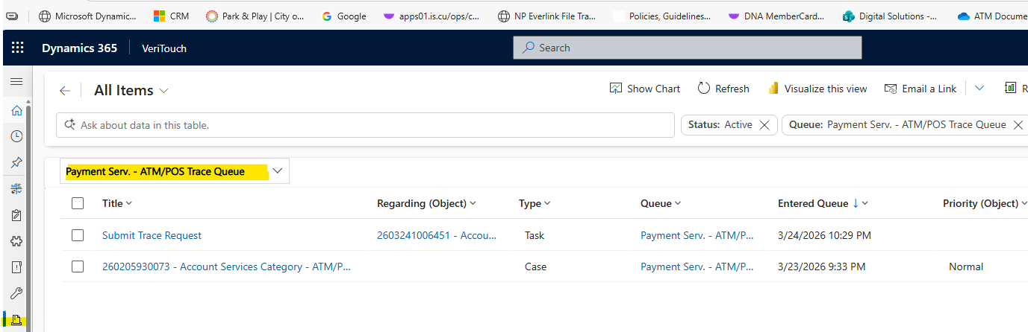
*Check CRM-payment services-ATM/POS Queue throughout the day*
-Confirm the ATM Trace information provided by staff is correct:
Open members’ account and find the transaction they are requesting to be sent out.
*Look under the “CARD TXN” in the Balance History tab.
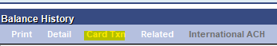
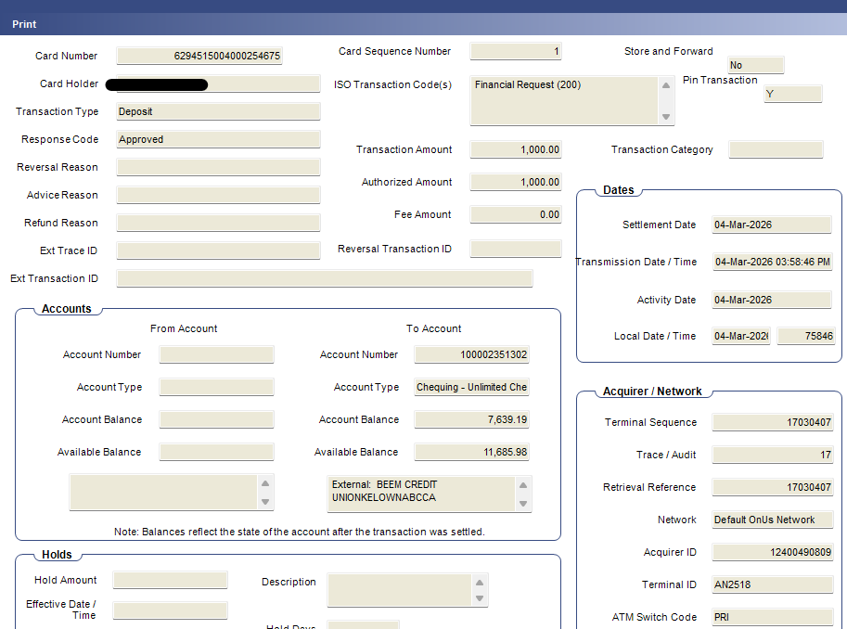
Confirm the correct transaction number, amount, and date.
If incorrect, reply to the email asking for correct info. OR Update CRM asking for correct information.
*POS TRACE PROCEDURES (starting on page#9)
2 Types of traces for ATM:
BEEM members who have an issue at any ATM that is not part of Ficanex. This could be a stand-alone ATM or a big bank Atm. It is not on any of the bin lists. We send through Central 1-Service Now.
Need to be one of these ATM Types for Central 1 to submit a trace
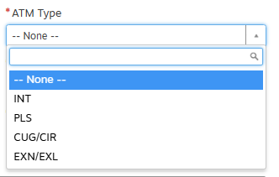
Look up transaction on ATM Everlink Report EVATM002:
S:\ATM\Everlink-ATM\YYYY\MM\DD
Easiest way to do this: Edit-find- type in the Pan number:
*Take a snip of transaction make sure to include Terminal ID, Pan #, Stlm AMT, and Ref/Trans #
Create a word Doc. Paste the Snip. Save in ATM POS TRACEs Pending folder using the date and amount. (Ex: 02 Jan 200.00 ATM Trace)
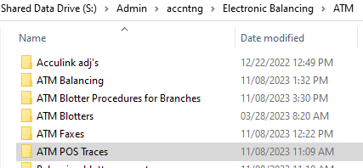
Open Central 1-Click ServiceNow
Production Applications – Client Centre
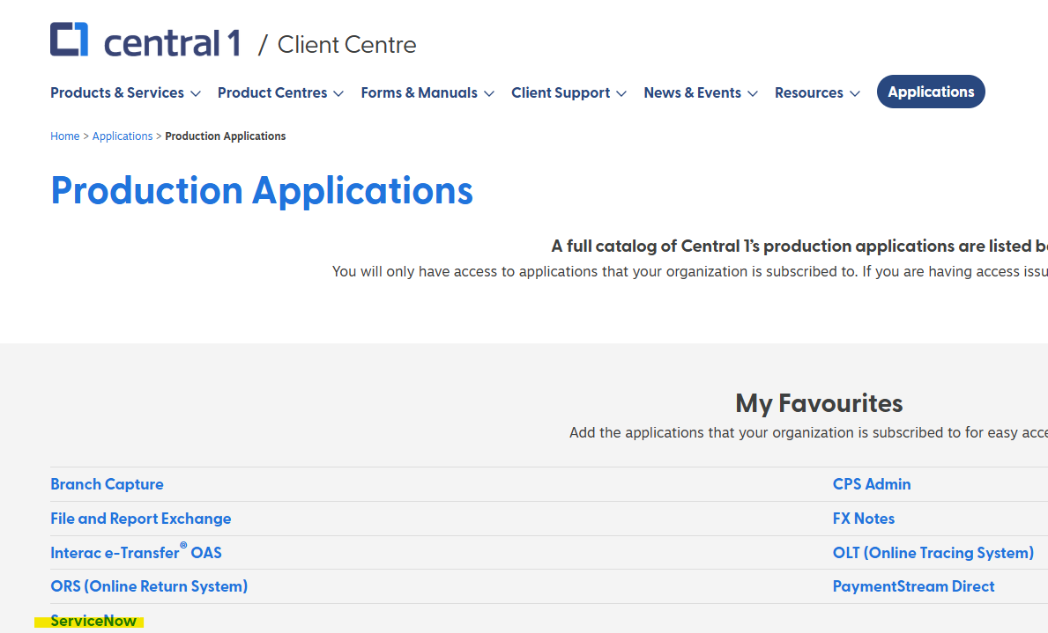
Click on Service Catalogue
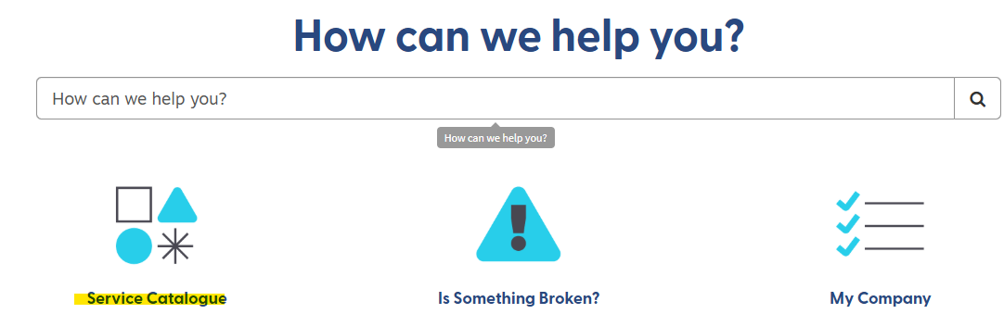
Open Electronic Payments
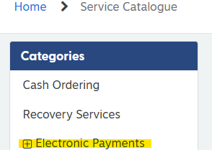
Click ATM Request
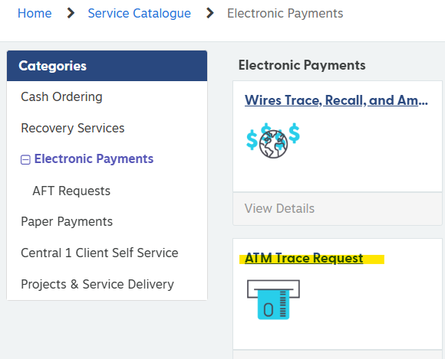
Complete Form
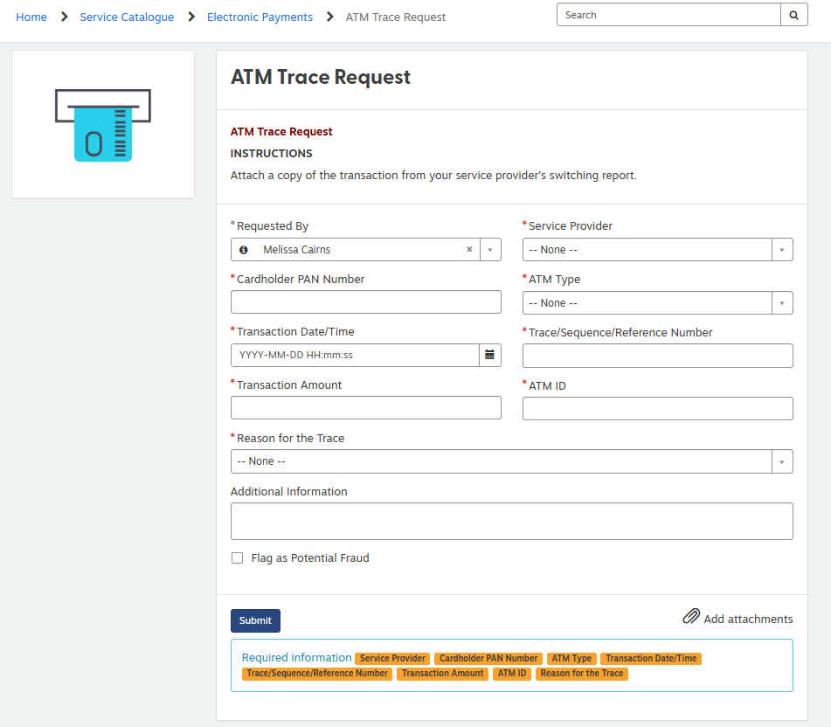
*In addition information section-have to write something*
Examples: “Please investigate” “Please debit us as our machine is over”
****** Attach Word doc that you saved in ATM POS Traces pending folder. ******
Before clicking submit
After hitting submit- there will be a RITM# - make sure to take a snip and paste into the word doc created for this Trace.
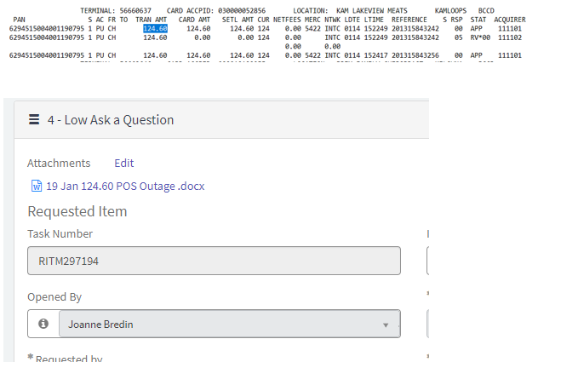
*RITM# is how you can track the trace in Central one.

ATM Trace on BIN List
If it is an ATM that is on our bin listings (Exchange or National) we sent out the fax for the trace including the Request for Information form and a Word doc (Snip of Report showing the transaction in question). We do not send it to Central 1.
Form is found here:
S:\Admin\accntng\Electronic Balancing\ATM\ATM Faxes & Advice Forms\Request for Information Advice Forms
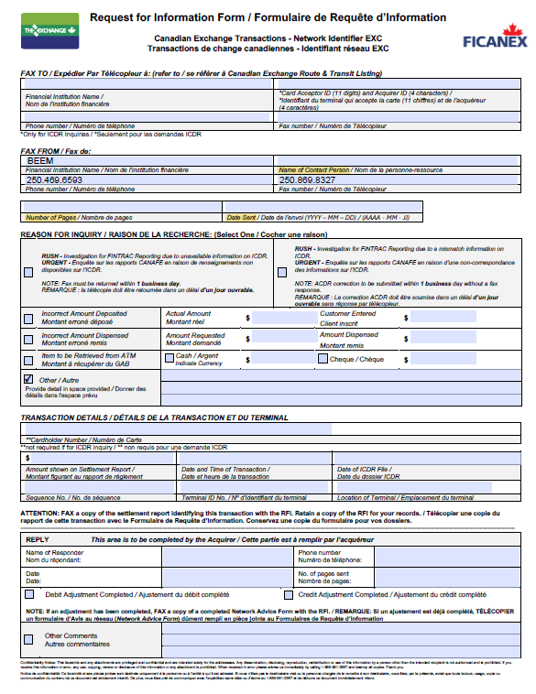
Next look up transaction on ATM Everlink Report EVATM002:
S:\ATM\Everlink-ATM\YYYY\MM\DD
Easiest way to do this: Edit-find- type in the Pan number:
Fill out the blue section, with as much details as possible. Amount, Pan#, Trans/Ref#, Machine#, location. EvATM002 report has information needed for the form.
*Take a snip of transaction make sure to include terminal ID, Pan Number, Stlm AMT, and ref number
*Open a word Doc. Paste the image in it. Save in ATM POS TRACEs Pending folder using the date and amount for the name. (Ex: 02 Jan 200.00 atm Trace)
Email: reply all (make sure ATM/POS box is cc’d) let staff member know we have sent off the trace and will update them once we hear back.
Mark as a trace (Right-click- categories-Traces) and drag it to the Traces folder, as you may not be the person who finishes this.
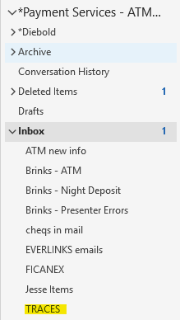
CRM: Add a note to the CRM letting them know we have sent the Trace off to Central 1 or another FI and will update once we hear back.

After a few weeks (it could take up to 6 to 8 weeks) you should hear back from Central that the funds will be returned. They will come in as a CHQ4 and will also be in the CDJ. You will post the funds back to the member, with the offset being the Admin Central 1 gl. Please be sure to use the code that is in the CDJ, for matching on the CCR. Take a snip of the trans before it is processed to put in the trace document to show that you have completed it.
Once that is done, contact the person who sent in the trace to let their member know that the funds have been returned.
How to initiate an ATM trace for a Non-Members
- Will show on the ATM blotter or on the Brinks Treasury Report (Thursdays) if transaction was completed on a machine balanced by BRINKS.
2 ways to send out a trace for non-members (Similar to BEEM mbrs).
1-If the pan number is on the Bin Listings (Exchange and/or National) we
fax out a Request for Information (See process above for our member)
2-If the pan number is not on the bin listing, we send out the trace thru Central 1, Service now. (See process for our member above)
If there is a confirmed Presenter Error on the blotter: 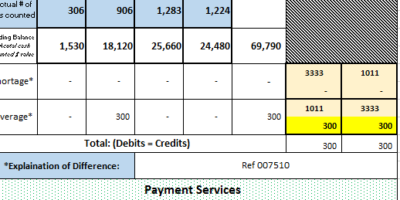
Check ATM Everlink report
S:\ATM\Everlink-ATM EVATM003 report
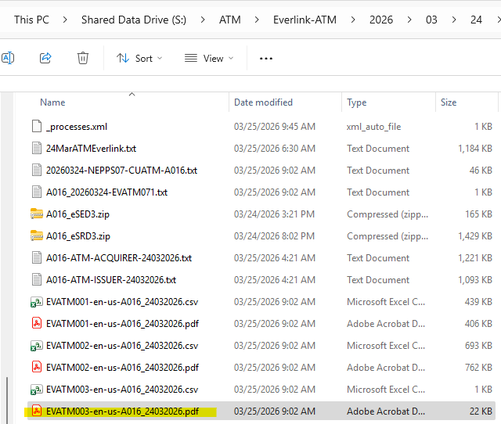
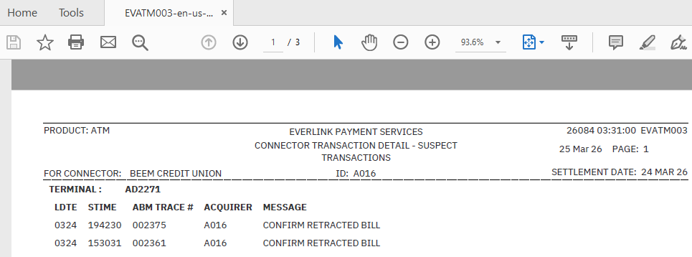
Open the EVATM002
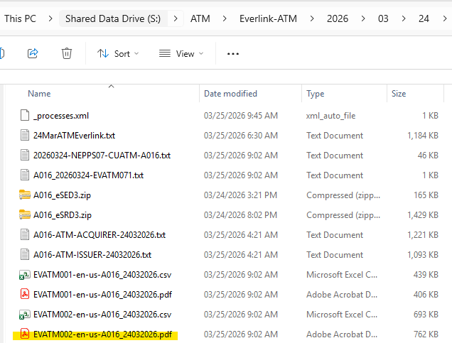
Find on ATM journal
Q:\ATM\Journal
*Confirm with branch that they want us to send out the funds* (email from them)
Submit in Service Now (See above how to submit)
*Additional Information-“Please debit us, thank you.”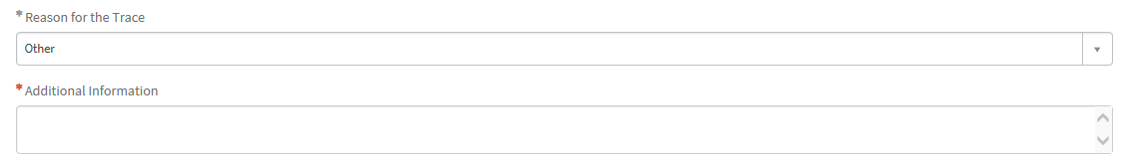
SNIP the RITM#, initial and the date sent out.
When we hear back from C1, they will send the adjustment as a CHQ4. We would post this between Admin Central1 and the branches “ATM Cash Differences”gl. Please be sure to use the code that is on the CDJ for it to match CCR.

POS Traces:
ATM/POS trace requests are sent to the *Payment Services - ATM/POS psatrm@interiorsavings.com or via CRM Queue.
*CRM is not set up properly- sometimes get email to ATM/POS box. No section set up for staff to input information.
*Check CRM-payment services-ATM/POS Queue throughout the day*
-Confirm the POS Trace information provided by staff is correct:
Open members’ account and find the transaction they are requesting to be sent out.
*Look under the “CARD TXN” in the Balance History tab.
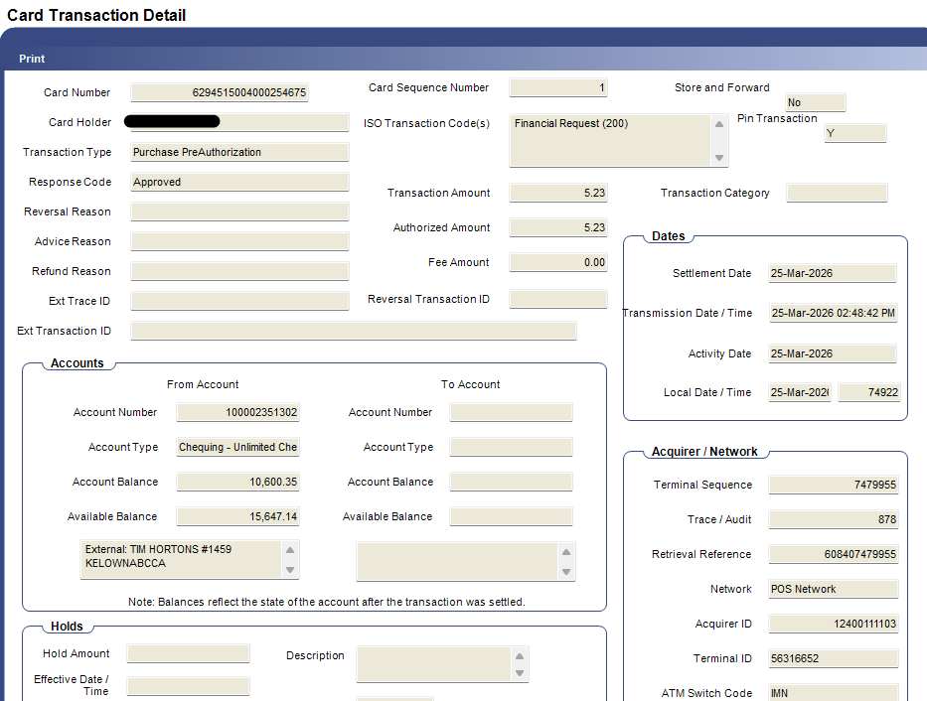
Confirm the correct transaction number, amount, and date.
If incorrect, reply to the email asking for correct info. OR Update CRM asking for correct information.

Look transaction up on report-EVPOS001
S:\ATM\Everlink-POS\YYYY\MM\DD
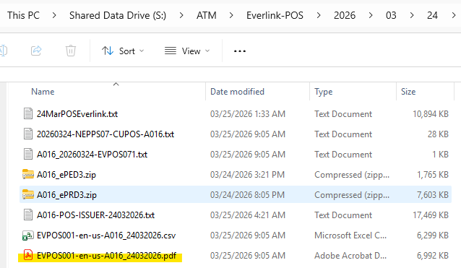
Easiest way to do this: Edit-find- type in the Pan number:
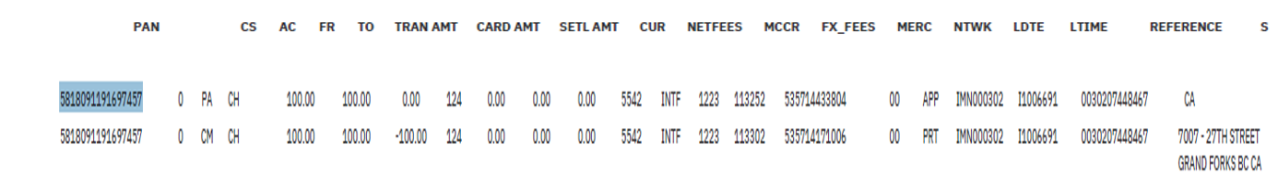
*Take a snip of transaction make sure to include Terminal ID, Pan #, Stlm AMT, and Ref/Trans #
Create a word Doc. Paste the Snip. Save in ATM POS TRACEs Pending folder using the date and amount. (Ex: 02 Jan 200.00 ATM Trace)
Open Central 1-Click ServiceNow
Production Applications – Client Centre
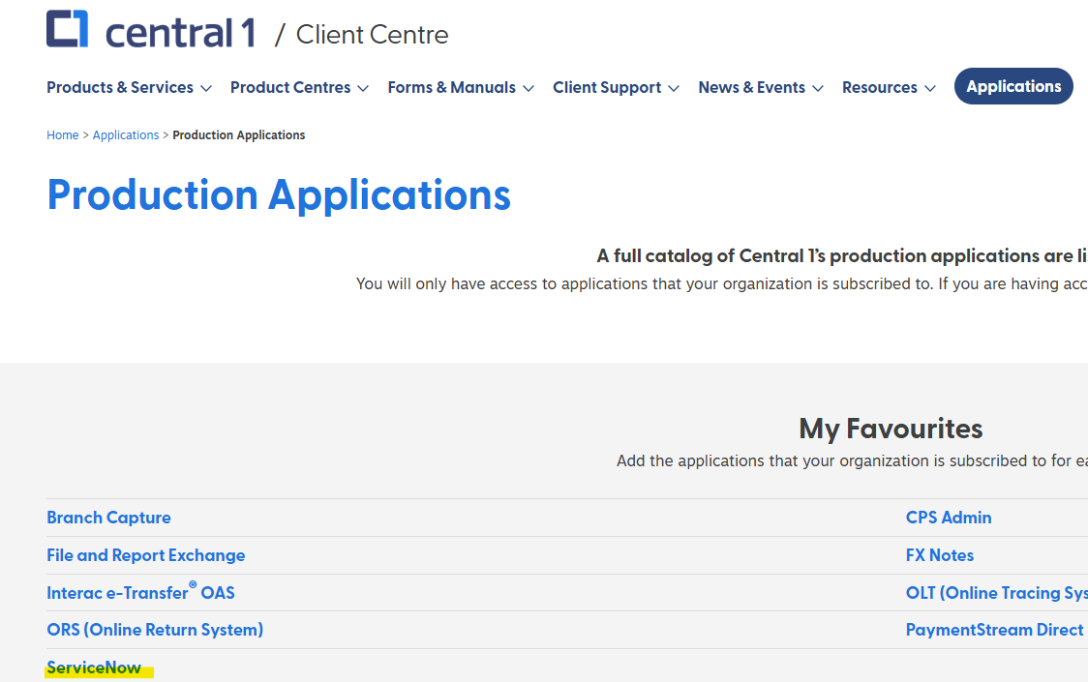
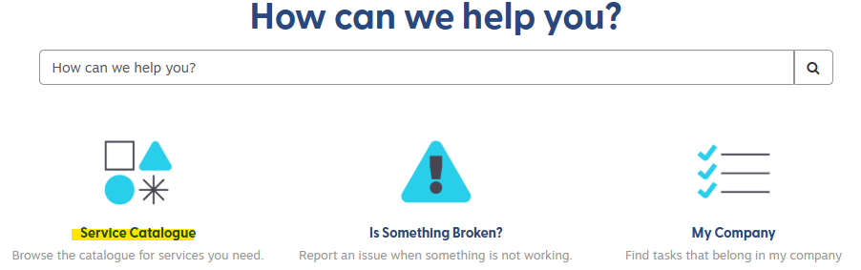
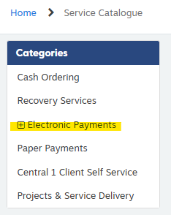
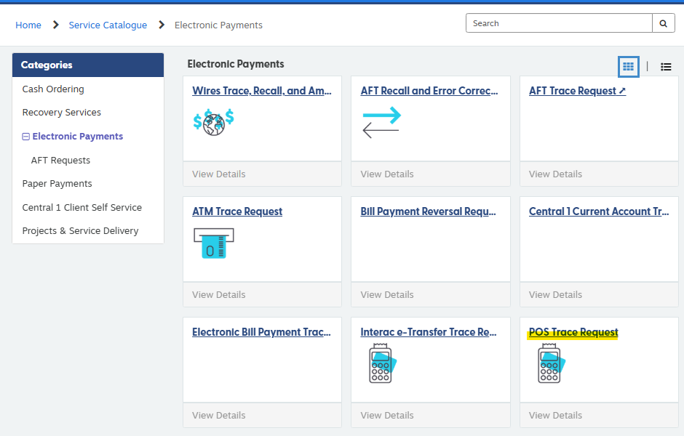

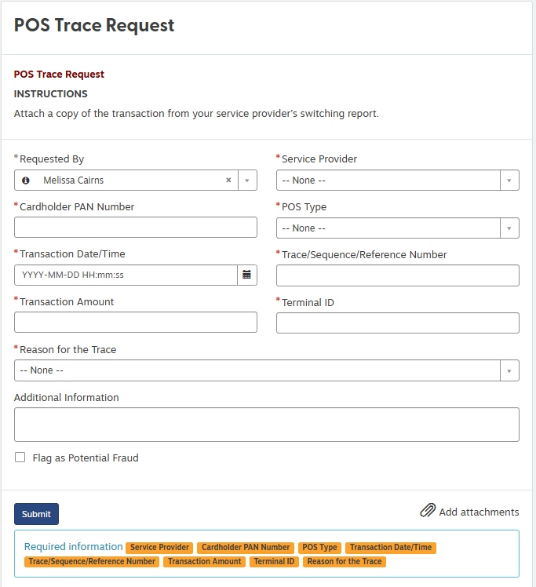
Complete form (*)
Additional information section- type in a note
Examples:
“Please investigate” “Member used another form of payment” “Member was debited twice”
****** Attach Word doc that you saved in ATM POS Traces pending folder. ******
Click Submit
*SNIP RITM#- Paste in word doc created for POS trace
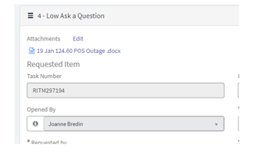
RITM# used for tracking trace request in Central one
Email: reply all (make sure ATM/POS box is cc’d) let staff member know we have sent off the trace and will update them once we hear back.
Mark as a trace (Right-click- categories-Traces) and drag it to the Traces folder, as you may not be the person who finishes this.
CRM: Add a note to the CRM letting them know we have sent the Trace off to Central 1 or another FI and will update once we hear back.

